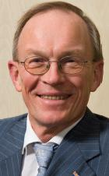 | Arnold Schilder  Chairman  International Auditing and Assurance Standards Board

Professor Arnold Schilder, RA was appointed to serve as the Chair of the IAASB for a three-year term beginning January 1, 2009. Prior to joining the IAASB, Prof. Schilder served for ten years as the executive director for banking supervision in the Managing Board of de nederlandsche Bank nV, the central bank and prudential supervisor of financial institutions in the netherlands. was a member of the Basel Committee on Banking Supervision and served as Chairman of its Accounting Task Force from 1999 to 2006. his service as a former member of the PIOB will benefit the IAASB as it continues to enhance its working procedures in serving the public interest. In addition, he is a part-time professor of auditing at the University of Amsterdam and is a past President of the Koninklijk nederlands Instituut van registeraccountants, IFAC’s member body in the netherlands. Previously, he was a senior international audit partner in PricewaterhouseCoopers (PwC) in the netherlands and worked for PwC and predecessor firms from 1972 to 1998.

阿诺德·斯奇尔德
主席
国际审计与鉴证准则理事会

阿诺德·斯奇尔德教授自2009年1月起担任国际审计与鉴证准则理事会（IAASB）主席，任期3年。在多年的职业生涯中，斯奇尔德教授担任过各类职务，主要包括：1998 -2008年，任荷兰中央银行管理委员会成员，负责银行监管；1999-2006年，兼任巴塞尔银行监管委员会委员和会计工作组主席；2005-2008年，兼任公众利益监督委员会（PIOB）成员；1994-1995年，兼任荷兰特许会计师协会会长；1972-1998年，曾担任荷兰普华永道会计师事务所国际审计高级合伙人；1991年至今，任阿姆斯特丹大学兼职教授。

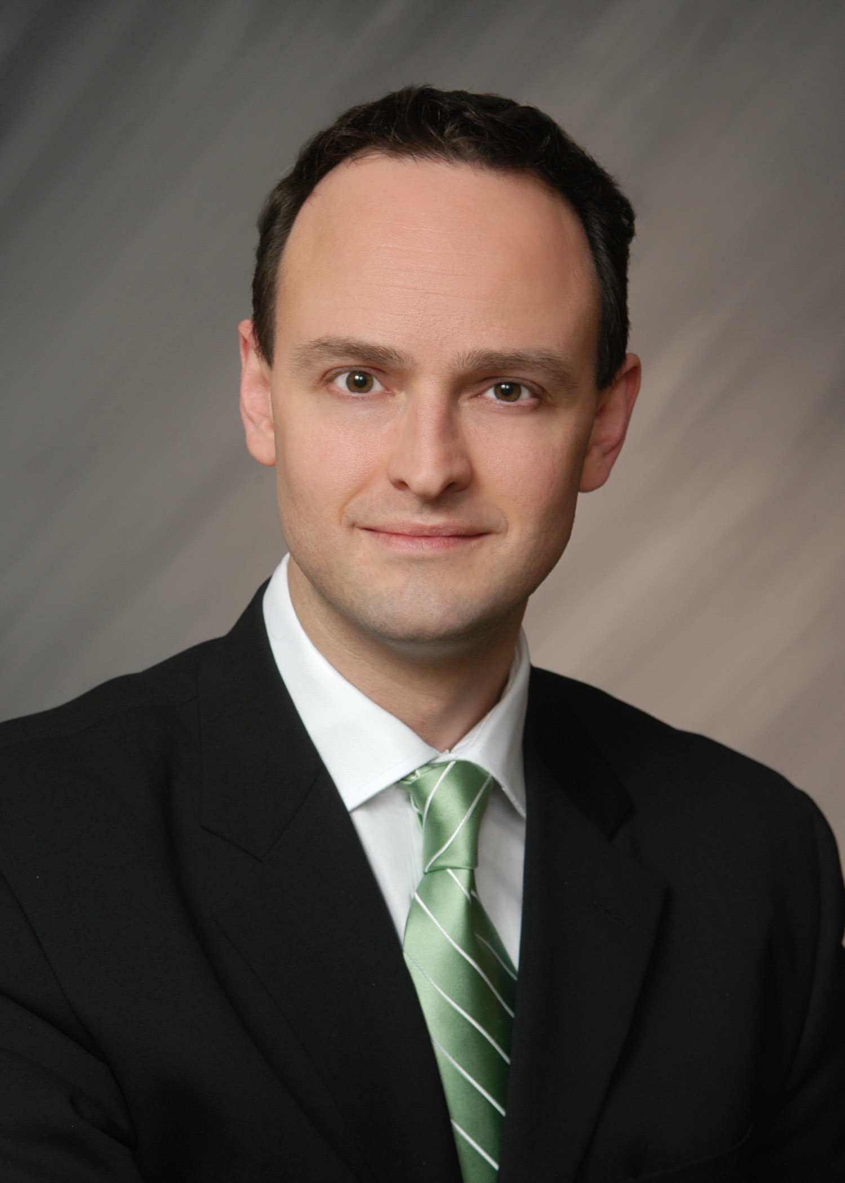 | James Gunn  Technical Director  International Auditing and Assurance Standards Board

James Gunn was named Technical Director of the International Auditing and Assurance Standards Board (IAASB) in March 2009. In his role, Mr. Gunn manages and oversees the work of the IAASB, including all IAASB projects and its strategic and operational activities. As Technical Director, Mr. Gunn plays a pivotal role in building positive relationships with external stakeholders.
Mr. Gunn joined the International Federation of Accountants in September 2002 and was appointed Deputy Director of the IAASB in March 2006. In this capacity, his responsibilities included overseeing the IAASB’s Clarity Project and monitoring the standard-setting activities of the major national auditing standard setters. Prior to this, between 1993 and 2002, Mr. Gunn worked at KPMG’s Canadian Assurance Practice and its Department of National Assurance and Professional Practice. He has extensive experience in audit and other assurance services, including those in connection with a number of significant capital market financing transactions. He has also lectured on the subject of auditing for several years.
Mr. Gunn is a Chartered Accountant in Canada. He is also a Certified Public Accountant.

詹姆斯 · 耿
技术总监
国际审计与鉴证准则理事会

詹姆斯 · 耿先生自2009年3月起担任国际审计与鉴证准则理事会（IAASB）技术总监。职责是管理和监督IAASB的工作，包括IAASB所有的项目以及战略和运营活动，并在与利益相关方建立良好关系方面发挥关键作用。
詹姆斯 · 耿先生2002年9月加入国际会计师联合会（IFAC），2006年被任命为IAASB副总监。担任副总监期间，他的职责包括监督IAASB明晰项目的运行情况，跟踪主要国家审计准则制定机构的准则制定活动。在此之前的1993-2002年，耿先生在毕马威加拿大会计师事务所工作。他在审计和其他鉴证服务领域具有广泛经验，曾参与一系列重大资本市场融资交易。他还曾多年从事审计授课工作。
耿先生是加拿大特许会计师和注册会计师。

