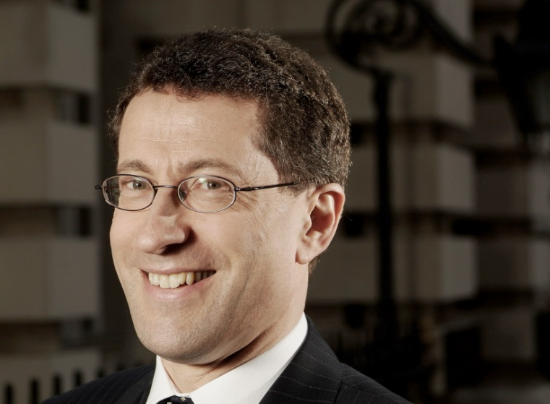

Robert Hodgkinson
Executive Director, Technical, ICAEW

As executive director, technical, Mr. Robert Hodgkinson is responsible for the ICAEW's seven specialist faculties in audit and assurance, corporate finance, finance and management, financial reporting, financial services, IT and tax. He also leads the ICAEW's work in corporate governance, professional ethics and liability, corporate responsibility and business law.

Robert was educated at the Manchester Grammar School and Corpus Christi College, Oxford where he studied Philosophy, Politics & Economics. In 1980, he joined Arthur Andersen where he qualified as a Chartered Accountant in 1983 and became a partner in 1992. He joined the Institute in October 2002.

Robert is a member of the board of the International Federation of Accountants (IFAC), the Prince of Wales Accounting for Sustainability Steering Group and the ICAEW Audit Firm Governance Working Group.

He has previously chaired the ICAEW’s Financial Reporting Committee and from 2000 to 2004 represented the UK accounting profession as a Vice-President of the European Federation of Accountants (FEE) in Brussels and as Chairman of its Auditing Working Party.

罗伯特·霍奇金森
技术执行总监，英格兰及威尔士特许会计师协会（ICAEW）

罗伯特·霍奇金森先生是英格兰及威尔士特许会计师协会技术执行总监。作为执行总监，罗伯特主要负责英格兰及威尔士特许会计师协会七个技术专业团体，包括审计与鉴证、公司理财、财务与管理、财务报告、金融服务、信息技术及税务，以及领导协会其他技术领域工作，包括公司治理、职业道德与义务、企业责任及商法。

罗伯特曾在曼彻斯特文理学校及牛津大学科尔普斯·克里斯蒂学院学习哲学、政治与经济学。他于1980年加入安达信，并于1983年获得英国皇家特许会计师（ACA）资格，1992年成为合伙人。罗伯特于2002年10月加入英格兰及威尔士特许会计师协会。

罗伯特是国际会计师联合会理事。同时，他也是英国查尔斯王子可持续性会计领导小组成员及英格兰及威尔士特许会计师协会会计师事务所内部治理工作组成员。

他于2000年到2004年期间，曾代表英国会计行业担任总部位于布鲁塞尔的欧洲会计师联合会（FEE）的副会长，还同时担任欧洲会计师联合会审计工作组的主席。

