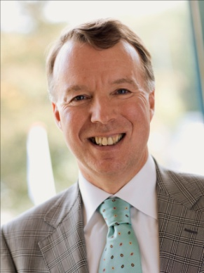

**MARTIN van ROEKEL**

Martin van Roekel is CEO of BDO International Limited, having taken on this role on 1 October 2011.

Martin joined BDO CampsObers in the Netherlands in 1975, becoming a partner in 1988. He immediately became involved with international business as the partner responsible for a number of international clients including US based clients. On a national level, he managed the Northeast region (11 offices) for six years and became a member of the board of BDO CampsObers Accountants & Adviseurs, representing Finance and IT, in 2002, moving to chairmanship of the board in 2004. In the same year, he became a member of the international BDO Policy Board and took over the chairmanship in 2007.

In 2009, Martin stood down from his role with BDO Netherlands and from the chairmanship of the international Policy Board in order to join the Global Leadership Team as Global Head of Network Development and CEO – Europe. His appointment reflected the importance of network development to BDO, and under his leadership the network grew from 110 member firms to 125, covering 15 additional countries.

Martin was born in 1956 and is married with two children. Martin has been active in a number of charitable organisations for many years and continues with his interests in telematics, scientific research and the support of talented young musicians.