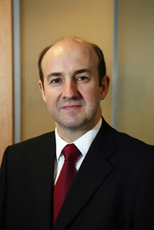

迈克尔·利泽先生

资深英国皇家特许会计师

首席执行官

英格兰及威尔士特许会计师协会

迈克尔·利泽先生于2002年1月加入英格兰及威尔士特许会计师协会（ICAEW），任财务及运营总监。2004年1月，他升任首席运营官兼执行总监，并同时进入ICAEW理事会。利泽先生于2006年12月开始担任ICAEW首席执行官。
利泽先生毕业于杜伦大学的法律专业，在校期间曾担任学生会主席。1986年，他在永道会计师事务所工作期间获得特许会计师资格。
1989年，利泽先生转入企业界，最初在约翰·拉伯特有限公司任欧洲区财务副总裁，后任约翰·拉伯特零售公司的执行董事。
在加入ICAEW之前，利泽先生曾在Spring集团工作，负责集团旗下英国最大的职业培训机构——Spring技能培训公司的运作。随后他担任了集团财务总监，不久后又任集团发展与战略规划总监一职。

Mr. Michael Izza FCA
Chief Executive
ICAEW

Mr. Michael Izza joined the ICAEW in January 2002 as director of finance and operations.

He was promoted to the role of chief operating officer and executive director in January 2004 when he also joined the ICAEW’s board. Michael then became Chief Executive of ICAEW in December 2006.

He qualified as a chartered accountant in 1986 with Coopers & Lybrand after graduating in law from Durham University where he was president of the student union.

In 1989, Michael moved into industry working initially as European vice president finance for John Labatt Limited and then managing director John Labatt Retail.

Before joining the ICAEW, Michael worked at Spring Group plc where he ran Spring Skills, the largest vocational training business in the UK, subsequently becoming group finance director and then group development and strategic planning director.

