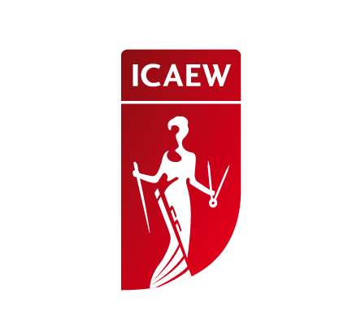
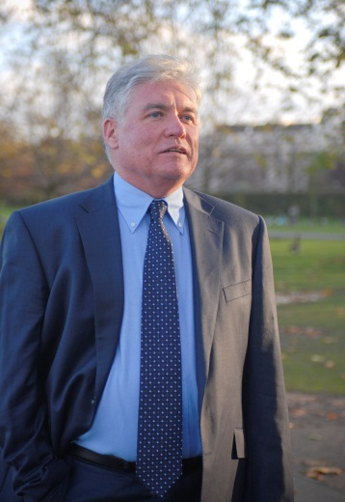

道格拉斯·迈克威廉姆斯先生

首席经济顾问

英格兰及威尔士特许会计师协会

首席执行官

经济与商业研究中心

道格拉斯·迈克威廉姆斯先生是世界著名经济学家之一。他因在过去的八年中对英国经济作出准确的预测而被誉为最佳经济预言家，并因此在2011年被授予四项奖项。
迈克威廉姆斯先生于20年前创建了名为经济与商业研究中心（CEBR）的商业经济咨询机构，并任首席执行官至今。他为伦敦金融时报指数（FTSE）100家公司中的25家公司及一些主要跨国公司提供咨询服务，如奔驰、丰田、IBM、甲骨文、斯特拉塔和沃尔玛等。
迈克威廉姆斯先生还为多家大型机构担任顾问，如英格兰及威尔士特许会计师协会（ICAEW）、英国小企业联合会、英国零售商协会等。
在创建经济与商业研究中心之前，迈克威廉姆斯先生曾任英国工业联合会首席经济顾问及IBM（英国）的首席经济学家。他还曾担任欧洲商业经济委员会（即欧洲企业联合会）主席一职。

Mr. Douglas McWilliams

Chief Economic Advisor, ICAEW

Chief Executive, CEBR

Mr. Douglas McWilliams is one of the world’s leading economists. Based in London, UK, he has been credited with the best forecasting track record for the UK over the past eight years and has won 4 awards for being the best UK economic forecaster for 2011.

He runs CEBR (the Centre for Economics and Business Research) a commercial economics consultancy which he set up twenty years ago. He advises 25 of the 100 UK FTSE companies, plus major international corporations like Mercedes Benz, Toyota, IBM, Oracle, Xstrata and Wal-Mart.

Douglas also advises major organizations like the Institute of Chartered Accountants in England and Wales (ICAEW), the Federation of Small Businesses and the British Retail Consortium.

Before he set up CEBR, Douglas was the Chief Economic Adviser to the Confederation of British Industry and Chief Economist for IBM (UK). He also once chaired the Economics Committee of Business Europe (the European federation of industrial organizations).

